|  |  |
| --- | --- |
| **AN ARTIFICIAL VISION**  BIONIC EYE | Abstract  In this entire world for those millions of people whose vision is impaired they have got eye gears for rectification but for the truly blind people whose vision is darkened we don’t have any therapeutics. So the recent advancement in the technology has driven the mankind towards various approach like artificial implants for those blind subjects and the bionic eye with retinal, ocular, sub retinal implant technique seems to be promising as it is an integration of electronics, biomedical and the embedded engineering which acts as the artificial eye in interpreting the materialistic images of the world and plays the active role of natural cones and rods for brain image interpretence. This paper gives an overview of various retinal implant techniques in channelizing the subjects vision through artificial intelligence and if it is commercialized becomes the potential device for the blind subjects to see and interpret the colorful world.  Rachana kulkarni |

**ABSTRACT**

**BIONIC EYE – AN ARTIFICIAL VISION**

**INTRODUCTION**

The science has done several wonders to the mankind. We always have seen prosthetics which helped in overcoming handicappers. Bi- medical engineers play an important role in shaping the course of the pros-the tics. Now it is the responsibility of Artificial Vision through Bionic Eyes. The Chips are designed specifically to mimic the characteristics of the damaged retina, cones, and rods of the organ of sight that are implanted with a Microsurgery. Whether it is Bio-medical, Computer, Electrical, or Mechanical Engineers – all of them have a vital role to play in the personification of Bionic Eyes. There is a hope for all the blinds in the form of Bionic Eyes. This innovative technology can add life to their vision less eyes. Later, this will create a revolution in the field of medical science. It is important to know certain facts about the organ of sight that is the human Eye before we proceed towards the technical aspects involved in Bionic Eye Systems.



**NEED FOR BIONIC EYE**

Due to the lack of effective therapeutic and remedial measures for Retinitis pigmentosa - RP and Age-related macular degeneration -AMD, it has lead to the development of experimental strategies to restore some degree of visual function to affected patients [1]. Since the rest of retinal layers are anatomically spared, several approaches have been designed to artificially activate this residual retina and bionic eye system. It is believed that electric stimulation of retinal neurons can produce light perception in patients who are suffering from retinal degeneration. Using this property we can channelize the functional cells to retain the vision with the help of electronic devices that assist these cells in performing the task of vision. We can make lakhs of people get back their vision at least partially. A design of an optoelectronic retinal prosthesis system which can stimulate the retina with resolution that corresponds to a visual activity of 20/80—which is sharp enough to orient yourself towards object, recognize faces, read large fonts, watch TV and perhaps most importantly lead an independent life.

**Working**

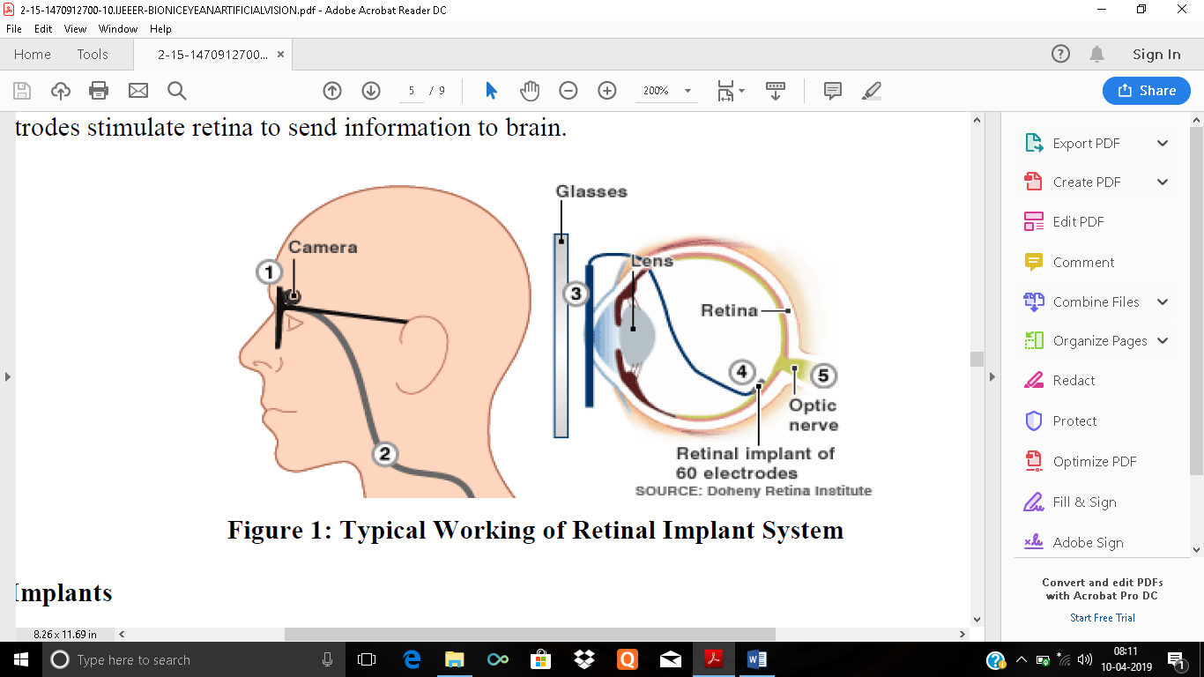

The working of Retinal implant system is depicted in Figure 1. Normally the vision starts when the light ray’s falls on the cones and rods and interpreted by the retina through optic nerves. These cells convert optical signals into electric impulses that are sent via optic nerve to the brain. Retinal diseases like ARM degeneration and RP destroy sight by rupturing these cells. With the artificial bionic eye, a miniature camera mounted on the eye-gear captures the images and wirelessly sends the information to a micro controller unit that converts the data to an electronic signal and re-transmits it to a receiver on the eye.

The receiver sends the signals through an optic cable to the microelectrode array, which triggers the pulse emission. The artificial retinal device thus bypasses default photoreceptor cells and it is transmitted as electrical signals directly to the retina’s remaining viable cells [11]. These pulses travel along optic nerves to brain. Then brain retrieves patterns of light and dark spots that correspond to the electrodes stimulation. Patients learn to interpret these visual patterns. It takes some training for the subjects to actually see a tree. At first, they see mostly light and dark spots. But after a due course of time, they learn to interpret what the brain is showing them.

Eventually they perceive those patterns of light and dark as a tree. Researchers are already planning a third version which consists of thousands of electrodes on the retinal implant and they believe it could allow subjects for reading, facial recognition capabilities purposes.

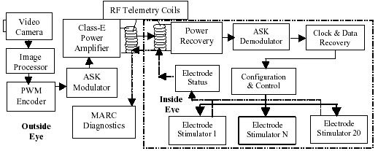

The Camera embedded on glasses to view image

* The Signals are sent to the hand-held device
* Processed information is sent back to embedded glasses and wirelessly transmitted back to the receiver Under the surface of eye.
* Receiver sends information to electrodes in retinal implant
* Electrodes stimulate retina to send information to brain.